WORKSHOP WEEK 3
Topics:
- WH questions about personal information.
- Demonstratives: This, that those, these
- Colors and clothes
- Possessive Adjectives: my, your, his, her, its, our, their.
- Family members
Competence:
Introduces him/herself and other people by using structures and vocabulary related to personal information to interact with others.
- Match the questions with the right answer:

1. What is his name? |  | a) Their favorite sports are soccer and basketball.
2. What is her favorite book? |  | b) Our favorite type of music is Salsa.
3. What is your favorite food? |  | c) My favorite food is pizza.
4. What are their favorite sports? |  | d) His name is Steve.
5. What is your favorite type of music? |  | e) Her favorite book is The Little Prince.
- Read the following phrases and correct the errors:
1. This is your shoe. _________________________________________________________________
2. These are my new colors.
__________________________________________
3. That is your English book. __________________________________________________________________
4. Those are her tennis shoes. __________________________________________________________________
5. This is your scissors. __________________________________________________________________
6. These are my new bag. __________________________________________________________________
7. That is your pencils. __________________________________________________________________
8. Those are her rubber. __________________________________________________________________

- Complete the following chart and let us know a little bit more about yourself:
Hello, this is me!
I am a: student of Marketing.
My name is: Julián Rivera.
My age is: thirty-six years old.
My birthday is: March 29, one thousand nine hundred and eighty-nine.
My favorite T.V. show is: Mr Robot.
My favorite food is:the Lasagna and the Pizza
My favorite sport is: The Football
My favorite color is: dark blue
My favorite subject is: advertising design
My favorite animal is: the dog and Cat
My hobbies are: I like to ride a bike, I enjoy watching documentaries and I like to listen to history podcasts

- Paste a picture of your family in the following chart. Then, write simple sentences describing it, using the verb to be, the demonstratives and the vocabulary studied during this week. Finally, record a video with this information and include the link of it in this file.
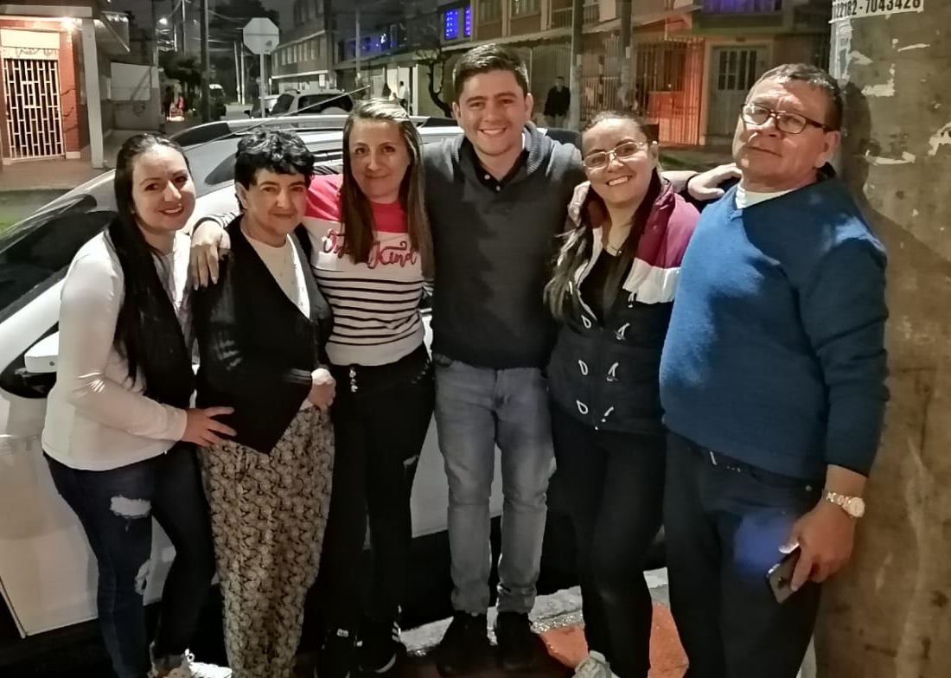
This is my family, they are my parents and my sisters. I start from the left of the screen: she is one of my sisters, her name is Leidy and she is two years older than me, the next is my mother and she is very affectionate with her children, the next woman is one of my older sisters, since she is a twin, her name is Rosana, the one in the middle is me, the woman on my left side is my other twin sister and her name is Ayde. Finally the man in the blue sack is my dad.

