ENGLISH I - WORKSHOP WEEK 3
Topics:
- Modal verbs in past
- Third conditional
- Phrase prepositions to express purposes
- General topics: Famous people, Heroes, Bands, Historical events
Competence:
Expresses regrets about decisions made in the past using modal verbs and conditionals to suggest possible solutions of what could have been done.

- . Use the third conditional form to complete each one of the following sentences:

a. If I hadn’t had a good English teacher, perhaps I we would not learned
b. If I hadn’t met the gym, I wouldn’t _now.
c. If I had read more in school, I would like to read more now.
d. I wouldn't have been late if I had placed the alarm closer
e. I would have gone further, I had studied more.

- Read the next text about Mars

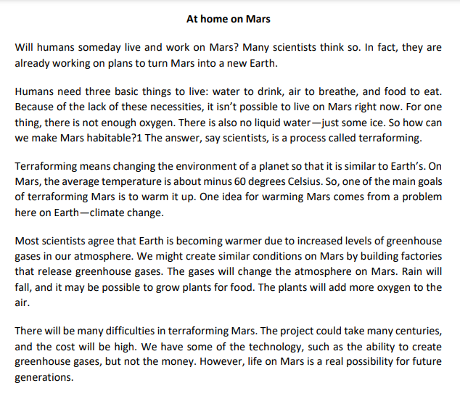
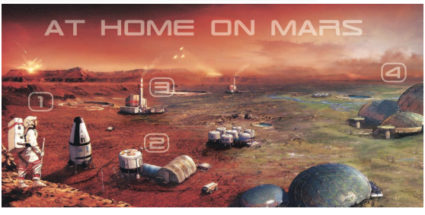

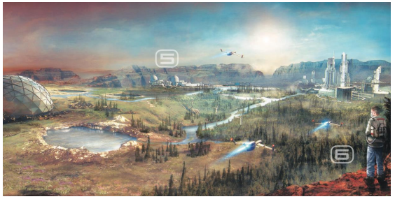
Retrieved from: https://ngl.cengage.com/assets/downloads/pathways_pro0000000046/pathwaysrw_1_unit6.pdf June 18th , 2021

- Complete the following sentences with information from the reading about Mars.
Paragraph _1__ - There is not enough oxygen on Mars – justice.
Paragraph _3__ - Terraforming Mars means making it similar to __ Earth .___
Paragraph _11 - For many years, humans probably won’t be able to living______ on Mars without special equipment.
Paragraph _6__ - The flight to Mars will take __six_____ months.
Paragraph 4_ - One way to warm up Mars is to build __factories_____. These will release __greenhouse___ gases into the air

- Put the steps to living on Mars in the correct order. Write the letter of the step in the correct place on the timeline.
a. People will build more habitation modules, spend more time on Mars, and learn more about it.
b. People will build domes and start to grow plants in them for food.
c. People will build factories on Mars to warm it up.
d. People will visit Mars on 18-month missions and start to build places to live.

NOW _d___ __b__ __c__ ___a_ +1000 YEARS

- List three items that will be different in the future. Think about what they will look like and how they will work. Note your ideas in the chart.
OBJECT | What it will look like / How it will work
cars | They will be totally different from the current ones because they will face other types of terrain.
Factories | They will be in charge of other types of processes appropriate to the needs of Mars
equipment | It will be lighter for daily use according to the needs

