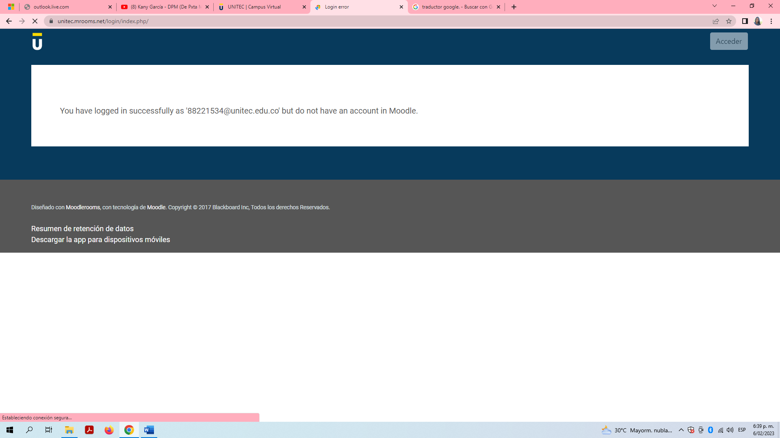

Esto es lo que me aparece en Ingles.
You have logged in successfully as '88221534@unitec.edu.co' but do not have an account in Moodle.

