ENGLISH I - WORKSHOP WEEK 3
Topics:
- Modal verbs in past
- Third conditional
- Phrase prepositions to express purposes
- General topics: Famous people, Heroes, Bands, Historical events
Competence:
Expresses regrets about decisions made in the past using modal verbs and conditionals to suggest possible solutions of what could have been done.

- . Use the third conditional form to complete each one of the following sentences:

a. If I hadn’t had a good English teacher, perhaps I wouldn´t have learnt English.
b. If I hadn’t met the love, I wouldn’t have the happiness.
c. If had read more in school, I would have won the exam.
d. I wouldn’t have been late if I had gone in time.
e. I would have gone further, I had shoes.

- Read the next text about Mars

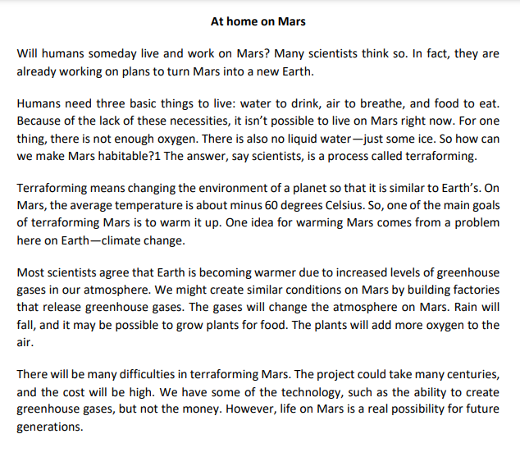
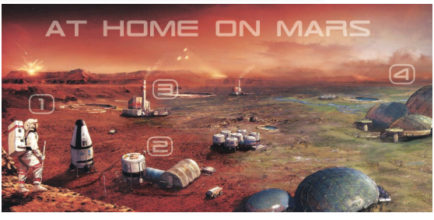

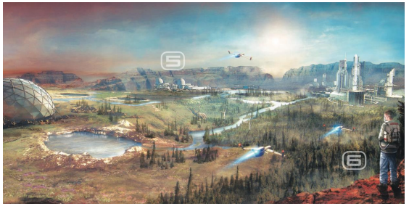
Retrieved from: https://ngl.cengage.com/assets/downloads/pathways_pro0000000046/pathwaysrw_1_unit6.pdf June 18th , 2021

- Complete the following sentences with information from the reading about Mars.
Paragraph 2 - There is no live on Mars – justice.
Paragraph 3 - Terraforming Mars means making it similar to Earth.
Paragraph 2 - For many years, humans probably won’t be able to breathe on Mars without special equipment.
Paragraph 6 - The flight to Mars will take six months.
Paragraph 4 - One way to warm up Mars is to build greenhouses.

- Put the steps to living on Mars in the correct order. Write the letter of the step in the correct place on the timeline.
a. People will build more habitation modules, spend more time on Mars, and learn more about it.
b. People will build domes and start to grow plants in them for food.
c. People will build factories on Mars to warm it up.
d. People will visit Mars on 18-month missions and start to build places to live.

NOW d a c b +1000 YEARS

- List three items that will be different in the future. Think about what they will look like and how they will work. Note your ideas in the chart.
OBJECT | What it will look like / How it will work
transport | The transport will instant and fast.
contact human | The contact human will be superficials and cold. But some people will have a very alert conscience and they would have telepatic
books | The paper book will not exist, because the digital book will become a success for the majority of people.

