Corporación Universitaria UNITEC

Programa educativo
Psicología
Materia
Ingles
Docente
Juan Camilo Vásquez Fonseca
Trabajo
Taller Semana 7
Estudiante
Daniel Quintero Ramírez
Código Estudiante
2520607@unitec.edu.co
Bloque o sección
CTP 103C2

Fuente de oro- Meta, Colombia 29 de Mayo del 2023

ENGLISH III – WORKSHOP WEEK 7

Topics:
- Predictions on environment, transport, education, housing, economy, tourism, etc

Competences:
- Makes predictions about general topics by making approximations based on real facts with the purpose of guessing actual events.

Predicting the future and describing plans

Through this activity students will apply in context grammatical elements acquired during the course. Besides of developing their writing and narrative skills.

Instructions

- Look at the following picture and analyze it.

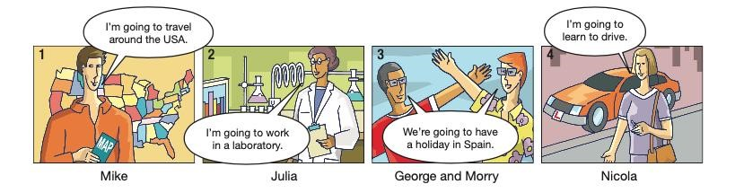

Image retrieved from: https://eltngl.com/sites/Life2e/teacher-resources/british-english/elementary/elementarygrammar-practice-worksheets

- Choose one of the characters included on it.

- Create a 150 words text in which you describe the activities to be developed per each one of them to fulfill his/ her goals and plans.

Example: Mike is going to travel by car, and he is going to eat hamburgers.

Página 1

Important!
- The student must use punctuation and connectors correctly.
- The student must write 120 words minimum and 150 words maximum.
- The text must be original. It is not possible to copy it from any kind of source.
- Application of the topics and guidelines above, on the step by step, mentioned.
- The document has to be uploaded to the platform in PDF format.

Evaluation criteria
CATEGORY | DESCRIPTOR | SCORE
Grammar use 12 points | Application and proper use of the grammar resources to make predictions and describe future plans/arrangements.
Complete text 12 points | The text has a minimum of 120 words, and it is composed of the introduction, development, and conclusion.
Coherence 12 points | Logical relation between the provided information and its sequence.
Natural use of language 12 points | Provision of information through the own construction of ideas.
Vocabulary, spelling, and punctuation. 12 points | Correct spelling of the words and use of verbs, connectors, synonyms, and punctuation marks.
 | Total points:

Solution
Character: Mike

Mike is a young and adventurous individual who is determined to make a positive impact on the environment. He believes that protecting the environment is crucial for future generations. To fulfill his goals and plans, Mike has a clear set of activities in mind.

Firstly, Mike intends to actively participate in environmental conservation projects. He plans to volunteer for organizations that focus on reforestation, beach clean-ups, and wildlife preservation. By doing so, he hopes to contribute to the restoration of ecosystems and the protection of endangered species.

Additionally, Mike is passionate about sustainable transportation. He aims to promote the use of electric vehicles by organizing awareness campaigns and advocating for the development of charging infrastructure. Mike plans to collaborate with local governments and businesses to encourage the adoption of eco-friendly transportation options.

Furthermore, Mike is committed to raising awareness about sustainable living practices. He plans to give educational presentations in schools and community centers, sharing practical tips on waste reduction, recycling, and energy conservation. By spreading knowledge and inspiring others, Mike believes he can make a significant impact in promoting a greener lifestyle.

In conclusion, Mike's activities revolve around environmental conservation, sustainable transportation, and promoting eco-friendly practices. With his dedication and determination, he aims to create a more sustainable future for all.

